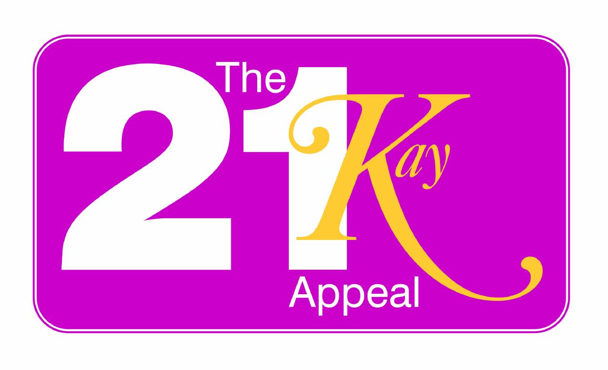
Raising 21K for 21Years of Care

16 Claremont Drive
Bridgnorth, Shropshire
WV16 4LE
the21kayappeal@googlemail.com
12 March 2009

The 21Kay Appeal

The 21Kay Appeal has been launched with the aim of raising £21K for 21 years of care within the NHS system. The money raised will go towards diagnostic equipment for the detection of bowel cancer and other serious bowel conditions. To give something back – a tribute to the many talented Surgeons, Doctors and Nurses – to show support to the system which helped me and helps all those facing ill health.

In 1988 I was diagnosed with FAP (familial Adenomatous Polyposis) at the age of 25 and having recently given birth to my first child. I was fortunate enough to receive an early diagnosis and within days underwent surgery to remove my colon. Without this operation, and the ongoing NHS care I have received during the last 21 years, I would not be alive today.

I am grateful for the life I have been given and as a tribute to the many talented Surgeons, Doctors and Nurses and to show support to the system, which helps me and helps all those facing ill health, to give something back to our health system will be a dream come true. By giving our time effort and hard earned cash today to help make someone else’s day better tomorrow.

Not intending or meaning to enter into any political debate when I say, from what I can see and hear, our health system is unable to provide every thing for everyone – in an ideal world there would be enough funds and resources to treat everyone with every piece of up to date equipment available – but sadly there just isn’t that capacity.

We are working very hard to raise funds to help bring these 2 pieces of much needed diagnostic equipment to The Shrewsbury and Telford Hospital NHS Trust:
- An endo-anal ultrasound scanner and probe (54K) used to detect early rectal cancer and assess damaged muscles, particularly in women after childbirth injuries, is needed to replace the current outdated 2 dimensional 14 year old piece of equipment which has served us well but is now prone to breaking down. The new equipment will give a 3 dimensional image with far better information delivered to the surgeon without the worry of the equipment developing a fault.
- A transanal endoscopic microscope (47K) used for resecting large rectal polyps is currently unavailable in our cancer region: Stoke, Stafford, Wolverhampton and Shropshire, patients have to travel to Birmingham or Liverpool to receive this treatment at the moment, a journey they and their families could well do without.

The 21K Appeal now has a total of 26 events and activities to raise funds. The 3 main events are:
- The Bridgnorth Walk on 25 May – currently we have a team of 28
- The Sponsored Tandem Skydive on 20 June – currently we have a team of 10
- The Solstice Walk on 21 June – we have a team of 21
There will also be a grand finale event to draw to a close the appeal with a live music on 10 October, for which 200 tickets will go on sale.

There will be a 21K team t-shirt, which has corporate sponsorship, for all members of the 3 main fundraising events to wear. The appeal leaflet has been produced and printed for no charge. The web site: www.shrop.net/the21kayappeal has been built for no charge. There will be no postage, stationery or administration costs to the appeal.

All the funds raised will be presented on 10th October to Mr Schofield MS FRCS, Consultant Surgeon in the colorectal unit at The Shrewsbury and Telford Hospital NHS Trust.

It is easier for people with bowel conditions to talk and listen without embarrassment about bowel issues as it becomes just part of life for us. For the majority of the people who are actively fundraising for the 21K appeal this is a whole new area. It is a subject many choose to ignore or ‘sweep under the carpet’. Hopefully the appeal will also raise awareness – it is not that long ago that cancer was known as the big ‘c’ and talked about in whispered tones and tuts – it is also not that long ago that other forms of cancer where also felt to be too embarrassing to discuss e.g. breast, testicular and prostrate cancers, they are far more openly discussed now. Unfortunately bowel cancer and bowel disorders are not yet easily talked about – we know many find it difficult to discuss and many find it difficult to hear about. Wouldn’t it be great to start a new trend of openly talking about a taboo subject!

I look forward to the day when, like other cancers and disorders, bowel cancer and bowel disorders are not something that is hidden and people needing medical attention seek it sooner rather than later without embarrassment.

Kay Shinton

