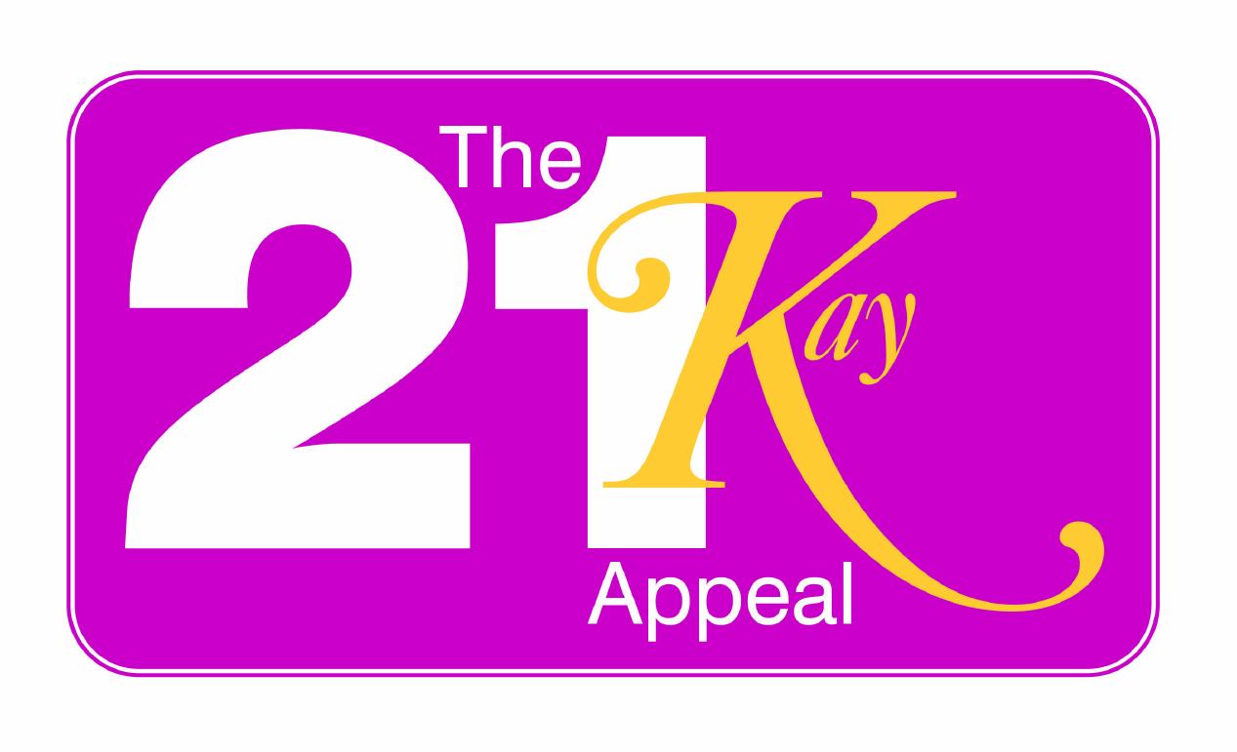
Raising 21K for 21Years of Care
16 Claremont Drive
Bridgnorth, Shropshire
WV16 4LE
www.shrop.net/the21kayappeal

17 October 2009

LATEST NEWS and PRESS RELEASE

THE 21KAY APPEAL

The Appeal Party took place on 10 October 09 at the Castle Hall, Bridgnorth. The 125 people who came to join in the celebrations were entertained with wonderful live music from local band the Dockers; the dance floor was busy all night!

The promotional cheque presented to Mr Schofield MS FRCS Consultant Surgeon at The Shrewsbury and Telford Hospital NHS Trust was for £21,605.21p – following further funds raised on the evening a total of just over £22,000 was raised.

In all 36 events and activities took place over 13 months with 81 people joining in the FUNdraising team – some people were involved in multiple events and activities, added to this there were also companies and individuals who helped or sponsored the appeal in many different ways. Events and activities took place all over the country from Manchester to Shropshire to Birmingham and Solihull to Gloucestershire, from Reading to Devon and all the way down to the Isle of Wight. A fundraising event / activity has taken place in each place I have lived in, and more!

With much joy and excitement I can now announce: The funds raised doubled overnight! The 21Kay Appeal will now be presenting a cheque for £44,021.21p to The Shrewsbury and Telford Hospital NHS Trust. The Roy Fletcher Charitable Trust matched the funds raised and sent me a cheque for £22,0000! I extend my deepest and heartfelt gratitude to them for their enormous help and support in making my dream come true, they have made a huge difference to the outcome of this appeal and indeed to the lives of all the patients who need treatment from this equipment, for without them we would not be in the wonderful position we are in now, I cannot thank them enough.

Libby Cooper a Trustee of the Roy Fletcher Charitable Trust said:
“The Roy Fletcher Charitable Trust has taken an interest in The 21Kay Appeal and once the Trustees knew how much the appeal had raised they decided to match the funds raised. We are very impressed by the effort and determination to raise this amount of money. The Roy Fletcher Charitable Trust are delighted to help so many people in Shropshire and surrounding area’s” end quote.

The fabulous news doesn’t end there! It is also magnificent news that The Shrewsbury Colorectal Trust Fund will also be donating £10,000 to make the total amount available £54,000 – enough to buy the endo-anal ultra sound scanner and probe. When installed in a few months once all the hospital procedures and training has taken place, patients needing this treatment will no longer have to travel to another health authority to receive the help they need. It will make a difference to a great number of patients – it is my dream come true – to be able to make a difference and help other fellow patients. I cannot describe how happy I am to be able to help in this way.

Mr Schofield MS FRCS, Consultant Surgeon from the Colorectal unit at The Shrewsbury and Telford Hospital NHS Trust said:
“We are greatly indebted to Kay Shinton for a truly phenomenal fund raising effort. This together with the Roy Fletcher Charitable Trust and the Royal Shrewsbury Colorectal Trust will enable the purchase of an endo-anal ultrasound for the Colorectal Unit at Shrewsbury. The Endo-anal ultrasound is used to stage early rectal cancers and polyps, which we expect to see even more frequently with the introduction of the national colorectal cancer screening programme. It can also be used to assess the anal sphincter particularly in women following childbirth and help in the management of incontinence. No longer will patients have to travel elsewhere for these investigations and it is a very valuable extension to the colorectal service in Shropshire.” End quote.

Following this great success I have made the decision to keep The 21Kay Appeal open for anyone who would like to make a donation or raise funds towards the other vital piece of equipment the colorectal unit need: a transanal endoscopic microscope. It was a very difficult decision for the colorectal surgeons to have to choose between the 2 pieces of equipment, as there is such a desperate need for both. I am not personally able to continue at the rate I have been going at since launching the appeal, but by keeping the 21Kay Appeal open it enables a continuation of fundraising possible. Residents of Shropshire and surrounding areas will be able to decide if they would like to make it possible to make this piece of vital equipment available in Shropshire for the patients who need this treatment. Currently the transanal endoscopic microscope is not available in our cancer network – Stoke, Stafford, Wolverhampton and Shropshire, patients needing this specific treatment are transferred to either Birmingham or Liverpool and with the introduction of bowel screening this may affect more and more patients.

If you would like to help to make a difference to patients who need this treatment by making a donation or FUNdraising to bring the endoscopic microscope into Shropshire please do get in touch at: the21kayappeal@googlemail.com.
Further details of the 21K appeal can be seen at: www.shrop.net/the21kayappeal

17Oct 2009

The 21Kay Appeal

For anyone who has not heard about The 21Kay Appeal it is a fundraising effort to help with the purchase of 2 pieces of much needed diagnostic equipment for the colorectal unit at The Shrewsbury and Telford Hospital NHS Trust. The appeal aimed to raise £21,000 for 21 years of care to show support to the system which helps me and all those facing ill health, for without the talents and skills of surgeons, doctors and nurses, I would not of had the benefit of the last 21 years. Further details can be found at www.shrop.net/the21kayappeal.

