FAP Gene Newsletter March 2014

I am hoping that a few additions to our Newsletters will make it more interesting and also encourage you to send in ‘bits and pieces’ for future ones. These can be on any subject that you feel will be useful or of interest to others.

So where do we start? It has been a busy start to the year in regard to fundraising. In the past there has not been a real need for this with both John Roberts (John 1) and myself not that keen on the energy it might require.

However at our last Chat Day in September the thought that it might be the last one due to several reasons changed it all. We have always wanted to keep any registration fees at a low level and also have no membership fees. This is where John Nickels (John 2) our fundraiser suggested running the Chat Days and looking for funds to continue providing them on a free basis.
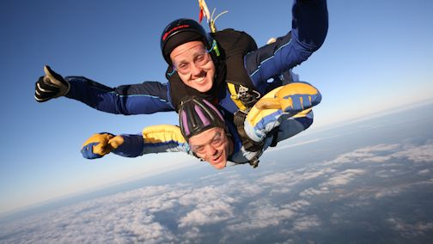

This resulted in Louisa and Russ offering to have FAP Gene as one of their beneficiaries for a Sky Dive Fundraiser. Russ took to the air and donated £200 to start John on his way. Rather him than me as he had a nine hour wait for clouds to clear. Full details are at

http://fapgene.com/fundraising3.html

John 2 then approached The Swadlincote Round Table who had made a previous donation from their Cheap Car Challenge in 2009. They seem to have a liking for us and agreed to cover the costs of this years Chat Day ensuring it would again be a free event. So together with Russ and Louisa’s help we can now expect them to continue for a number of years.

Almost a full page on this now and it continues with the Three Peaks Challenge. Mark and Vicky from Bury have chosen us to be one of their beneficiaries to enable us to promote awareness of FAP. This involves climbing the highest peaks in England, Scotland and Wales in 24 hours on June 20th. Any sponsorship is welcomed and full details on fapgene.com/fundraising2.html Our thanks go to all involved and also to The Branston Golf and Country Club near Burton upon Trent in Staffordshire for their continuing help with an excellent and relaxing venue.

A recent enquiry asked about if FAP was a disability in regard to discrimination at work. Whereas FAP itself is not a disability the after effects of surgery and other problems associated with FAP can be a factor. Until recently having preventative surgery and no cancer made it impossible to get help or advice through Macmillan Cancer Support. I was surprised and pleased at a recent meeting at Leicester University to hear this had all changed and that they have a ‘Fitness to Work Team’ also accessible by those with FAP. www.macmillan.org.uk/Home.aspx

The Ileostomy and Internal Pouch Support Group is a national charity with local branches that offers advice on Employment and Support Allowance, Disability Living Allowance, Attendance Allowance, Carers' Allowance, Disabled People's Rights and Discrimination at Work.
www.iasupport.org/about/welfare

FAP Gene Newsletter March 2014 Page 2

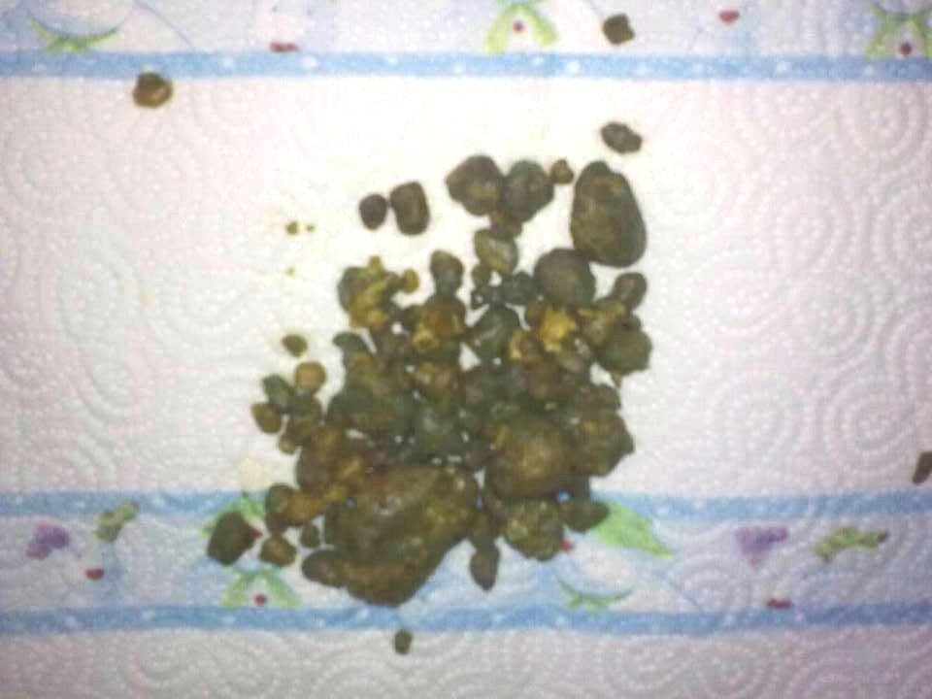
I am not one for trying alternative medication or therapy if not approved by my GP or consultant. Perhaps that is old age creeping in but I do find it fascinating what these are capable of delivering. So the next part is about an old Chinese Procedure for Gallstones. I include this as was recently told of a similar use with stunning results. FAP Gene always advise that you seek your GP or Consultants advice first. www.4optimallife.com/liver-cleanse-procedure-avoid-gallbladder-surgery Problems that were thought to be either a blocked bowel or gallstones seem to have been a problem for several members or their family recently.

So severe for one that after several admissions to A & E they took measures into their own hands. Not a pleasant taste to say the least but one of the stones passed was 40mm long or appx. an inch and a half. Afterwards all the pain had gone and upon showing them to their consultant they were told they were not gallstones but possibly from the small bowel.

Now back to our Free Informal Chat Day on September 20th at The Branston Golf and Country Club. Full details and registration form are available at www.fapgene.com/chatday2014.html Although this is an informal and relaxing event John Nickels johnnickels@fapgene.com would like any suggestions of ideas or topics so he has some form of schedule for the day. We are still looking for a new logo so perhaps a challenge for someone.

Already we have Wendy Chorley The Derby Hospitals Familial Cancer Nurse, Rio Diedrick The Internal Pouch Co-ordinator from The IA and Muditha Samarasinghe from The Polyposis Registry at St. Mark’s Hospital coming along.

The website continues to be popular around the world with just over 5,000 visitors in the past year. Amongst the most requested pages are Facebook, Curcumin, Kids FAP Book and Chat Days. We are still recommended as a valuable source of information by several organisations and have links from numerous academic and health websites across the world. This still only costs us around £32 a year and virtually now runs itself apart from the odd tweaking.

Our membership is 104 and we have 30 contacts whom we keep informed of our activities and news updates. Remember to let us know of any items you would like included in the next newsletter which should be out in June

On a personal note most of you know all about my travel companion Jimby The Russ Berrie Monkey and his 41 cousins who lodged with us. He has been re-housing some on E Bay and now just 24 remain. However we do have 4 Meerkats by using a well known comparison website. Now a word of caution. A certain energy website offered a £50 M and S voucher for changing to them. On looking further the actual tariff was £76 a year more!!! As they say nothing is free.

Mick Mason Secretary
The FAP Gene Support Group
www.fapgene.com

